# **Second Sunday of Christmas**



**Sunday, January 5, 2025**

Lutheran Church of the Living Christ

2725 Concord Drive

Florissant, MO 63033

**PRELUDE** “As with Gladness Men of Old” Michael Burkhardt

**WELCOME & ANNOUNCEMENTS** *(Details are on the slides and at the end of bulletin)*

**CONFESSION AND FORGIVENESS**

P: Blessed be the holy Trinity, ☩ one God, whose steadfast love is everlasting.

**C: Amen.**

P: Let us confess our sin in the presence of God and of one another.

*Silence is kept for reflection.*

**C: God-with-us, we confess that we have turned away those seeking shelter, claiming there is no room when we have plenty. We have made power and wealth our idols, while you show us true glory: a baby in a manger. We have overlooked the shepherds, expecting good news in prettier packaging. Too often, we have valued violence instead of your peace. Turn us from our ways to your ways. Grant us the grace to begin again. Free us from all that keeps us bound, and forgive our sin, through Jesus Christ, who gives himself for us. Amen.**

P: Hear the good news and rejoice! You are God’s chosen ones, holy and beloved, ☩ forgiven in Christ, and freed to respond in joy.

**C: Amen.**

**GATHERING HYMN** “As with Gladness Men of Old” ELW#302

**GREETING**

P: Beloved of God, called to be saints: Grace, mercy, and peace be with you all.

**C: And also with you.**

**PRAYER OF THE DAY**

God of all learning, When the boy, Jesus, stayed in the temple to learn from the elders, it was the elders who in turn learned from him. Teach us, Lord, as you have taught others, and grant us wisdom and willingness to learn. **Amen.**

**PSALM 2:7-8**

L: I will tell of the decree of the Lord: He said to me,

**C: “You are my son; today I have begotten you.**

L: Ask of me, and I will make the nations your heritage,

**C: and the ends of the earth your possession.**

**CHILDREN’S MESSAGE**

**PRIMARY SCRIPTURE READING**

L: The holy Gospel according to Luke, the 2nd chapter (verses 41-52)

**C: Glory to you, O Lord.**

41Now every year his parents went to Jerusalem for the festival of the Passover. 42And when he was twelve years old, they went up as usual for the festival. 43When the festival was ended and they started to return, the boy Jesus stayed behind in Jerusalem, but his parents did not know it. 44Assuming that he was in the group of travelers, they went a day’s journey. Then they started to look for him among their relatives and friends. 45When they did not find him, they returned to Jerusalem to search for him. 46After three days they found him in the temple, sitting among the teachers, listening to them and asking them questions. 47And all who heard him were amazed at his understanding and his answers. 48When his parents saw him they were astonished; and his mother said to him, “Child, why have you treated us like this? Look, your father and I have been searching for you in great anxiety.” 49He said to them, “Why were you searching for me? Did you not know that I must be in my Father’s house?” 50But they did not understand what he said to them. 51Then he went down with them and came to Nazareth, and was obedient to them. His mother treasured all these things in her heart.

52And Jesus increased in wisdom and in years, and in divine and human favor.

**SERMON** Pastor Matt

**HYMN OF THE DAY**  “Brightest and Best” ELW#303

**PROFESSION OF FAITH –** *The Apostles’ Creed*

**I believe in God, the Father almighty,**

**creator of heaven and earth.**

**I believe in Jesus Christ, God’s only Son, our Lord,**

**who was conceived by the Holy Spirit,**

**born of the virgin Mary,**

**suffered under Pontius Pilate,**

**was crucified, died, and was buried;**

**he descended to the dead.\***

**On the third day he rose again;**

**he ascended into heaven,**

**he is seated at the right hand of the Father,**

**and he will come to judge the living and the dead.**

**I believe in the Holy Spirit,**

**the holy catholic church,**

**the communion of saints,**

**the forgiveness of sins,**

**the resurrection of the body,**

**and the life everlasting. Amen.**

*Please be seated.*

**PRAYERS OF INTERCESSION**

Filled with good news of great joy, let us offer our prayers for the church, the earth, and all people.

*A brief silence.*

O God, you reveal yourself in this assembly. In water, wine, and bread, show us again and again your grace upon grace, that your church boldly testifies to your love. God of grace,

**receive our prayer.**

You reveal yourself in creation. In seedlings and planets, microorganisms and galaxies, awaken us to the cry of the earth. As you nourish your people like a watered garden, empower us to nourish our creaturely companions. God of grace,

**receive our prayer.**

You reveal yourself in every land and in the farthest parts of the earth. Deliver peoples who suffer under oppressive regimes. Thwart the foolish plans of unjust leaders. Give wisdom to our elected officials (*local leaders or governing bodies may be named*). God of grace,

**receive our prayer.**

You reveal yourself in every human being. Help us recognize your image in our siblings in Christ who are in the strong grip of addiction, depression, anxiety, hopelessness, or other illness (*especially*). Grant us compassion in our care for your people. God of grace,

**receive our prayer.**

You reveal yourself anew every day. In this new year, renew this congregation and its ministries in our witness to the good news of the incarnation (*specific ministry areas may be named*). Transform the way we have always done things into your new future for us. God of grace,

**receive our prayer.**

You reveal yourself in unified vision. Continue to guide the work of the Great Rivers Collaborative, including Zion Ferguson, Unity Bel-nor, Good Shepherd Hazelwood, St. Phillips, Atonement, Shepherd of the Hills, and Living Christ, reveal your direction for ministry into the future through your Holy Spirit. God of Grace,

**receive our prayer.**

*Here other intercessions may be offered.*

You reveal yourself in the lives of your holy ones. We give you thanks for those who set their hope on you, trusting the inheritance we receive in you. God of grace,

**receive our prayer.**

We commend these prayers to you, O God, trusting your grace made known to all, through the Word made flesh, Jesus Christ, our Savior and Lord.

**Amen.**

**MINISTRY SPOTLIGHT -** Thank you to Doris Stoehner and her committee of elves for the entertaining Fifty Plus Christmas Party. Ornaments were exchanged, carols sung, and a delicious lunch was enjoyed by all.

**SHARING OF THE PEACE** *Please stand as you are able*

P: The peace of Christ be with you always. **C: And also with you.**

*Share God’s peace in whatever way you are comfortable. Following this please be seated.*

**GATHERING OF OFFERINGS**

**OFFERTORY** “As the Grains of Wheat” ELW #465

**OFFERING PRAYER**

P: God of heaven and earth, from the beginning, you have called forth life, in which you take delight.

The trees, the fields, and the seas sing for joy. Bless now these gifts, received from your bounty,

that we may join the chorus of creation to tell of your salvation from day to day.

**C: Amen.**

**THE GREAT THANKSGIVING**

P: The Lord be with you.

**C: And also with you.**

P: Lift up your hearts.

**C: We lift them to the Lord.**

P: Let us give thanks to the Lord our God.

**C: It is right to give God thanks and praise.**

**P:** It is indeed right, our duty and our joy, that we should at all times and in all places give thanks and praise to you, almighty and merciful God, through our Savior Jesus Christ. By the witness of your saints, you show us the hope of our calling and strengthen us to run the race set before us, that we may delight in your mercy and rejoice with them in glory. And so, with the choirs of angels with the church on earth and all the hosts of heaven, we praise your name and join their unending hymn:

In the night in which he was betrayed, our Lord Jesus took bread, and gave thanks; broke it, and gave it to his disciples, saying: Take and eat; this is my body, given for you. Do this for the remembrance of me.

Again, after supper, he took the cup, gave thanks, and gave it for all to drink, saying: This cup is the new covenant in my blood, shed for you and for all people for the forgiveness of sin. Do this for the remembrance of me.

**LORD’S PRAYER**

P: Remember us and teach us to pray,

**C: Our Father, who art in heaven, hallowed be thy name, thy kingdom come, thy will be done, on earth as it is in heaven. Give us this day our daily bread; and forgive us our trespasses, as we forgive those who trespass against us; and lead us not into temptation, but deliver us from evil. For thine is the kingdom, and the power, and the glory, forever and ever. Amen.**

**INVITATION TO COMMUNION**

P: A child has been born for us, a Son given to us. Come, receive the gift of Jesus.

**C: Amen.**

**DISTRIBUTION** *Time is given for the sharing of bread and wine.*

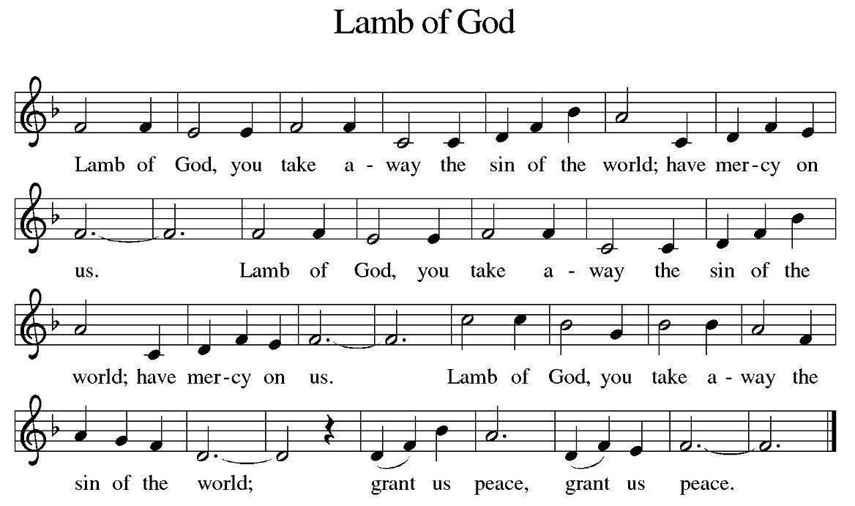

**DISTRIBUTION** **HYMNS** “Let All Mortal Flesh Keep Silence” ELW#490

*(Please stand as you are able)*

**COMMUNION BLESSING**

P: The body and blood of our Lord Jesus Christ strengthen you in God’s grace unto eternal life.

**C: Amen.**

**POST-COMMUNION CANTICLE** “Praise to You, O God of Mercy” ELW #208

**PRAYER**

L: Generous God, we thank you for the gift of life, for the bread of salvation. We thank you for coming among us, for leading us into peace. We thank you for showering us with mercy, for sending us into the world. Come, Lord Jesus, and go with us as we feed the hungry in your name.

**C: Amen.**

**BENEDICTION**

P: God of endings and beginnings, God in the darkness and the light, God, our hope for the journey, ☩ bless and keep you now and forever.  **Amen.**

**SENDING HYMN** “Let Our Gladness Have No End” ELW#291

**DISMISSAL**

L: Go in peace. The Word of God dwells in you richly.

**C: Thanks be to God.**

**POSTLUDE “**Three Kings March”  Michael Barker

**THIS WEEK at LCLC:**

Sunday (1-5) 8:00 AM Vocal Choir

9:15 AM Worship

No Adult Forum

Tuesday (1-7) NO Bible Study

11:00 AM Exercise Class

Thursday (1-9) 11:00 AM Exercise Class

11:30 AM Lunch Bunch

Friday (1-10) 9:00 AM Create Day

11:00 AM Bells

1. **January Lunch Bunch** will be @ Chimi’s Fresh Mex located at 520 N Hwy 67 in Florissant on January 9 at 11:30 am. We welcome everyone and the more the merrier! For reservations contact Joyce Meyer at 314-374-4135 or 314-838-3741.
2. **Create Day** - the next create day is January 10 from 9am-11am
3. **The 50+ planning meeting will be on Wednesday, January 15 at 10:30 a.m.** on the lower

level. Please bring a sandwich for lunch. Beverage and dessert will be provided. $10.00 dues

will be collected at the meeting.

**Trying something new**: This week we are starting a new season following the **“The narrative lectionary” -** The [Narrative Lectionary](https://www.workingpreacher.org/home-narrative-lectionary) is a four-year cycle of readings. On the Sundays from September through May each year the texts follow the sweep of the biblical story, from Creation through the early Christian church. The texts show the breadth and variety of voices within Scripture. They invite people to hear the stories of Abraham and Sarah, Moses and the prophets, Jesus, and Paul. Listening to the many different voices within Scripture enriches preaching and the life of faith. Learn more at www.narrativelectionary.org.

|  |
| --- |
| **January 5**  **Preaching/Presiding: Pr. Matt**  **Assisting Minister: Bill Kaeppel**  **Lector: Terry Calderwood**  **Live Stream: Gary & Laurie Brown**  **Musician: David Eggers**  **Ushers: Glenn Albers & Ann Schultz**  **Greeter: Jann Mueller**  **Altar Guild: Cathie Lehr & Joyce Meyer**  **January 12**  **Preaching/Presiding: Pr. Matt**  **Assisting Minister: Angela Bennett**  **Lector: Gary Brown**  **Live Stream: Rod Wallace**  **Musician: Greg Ott**  **Ushers: Levaughn & Sheila Smart**  **Greeter: Marilyn Wiley**  **Altar Guild: Karen Haynes & Sheila Smart** |