### **16th Sunday after Pentecost**

# 

**Sunday, September 8, 2024**

Lutheran Church of the Living Christ

2725 Concord Drive

Florissant, MO 63033

**PRELUDE** “Transfiguration” Paul Taylor

**WELCOME & ANNOUNCEMENTS** *(Details are on the slides and at the end of bulletin)*

**CONFESSION AND FORGIVENESS**

Blessed be the holy Trinity, ☩ one God, the God of manna, the God of miracles, the God of mercy.

**Amen.**

Drawn to Christ and seeking God’s abundance, let us confess our sin.

*Silence is kept for reflection.*

God, our provider,

**help us. We struggle to believe there is enough to share. We question your ways when they differ from the ways of the world in which we live. We turn to our own understanding rather than trusting in you. We take offense at your teachings and your ways. Turn us again to you. Where else can we turn? Share with us the words of eternal life and feed us for life in the world. Amen.**

Beloved people of God: in Jesus, the manna from heaven, you are fed and nourished. By Jesus, the worker of miracles, there is always more than enough. Through Jesus, ☩ the bread of life, you are shown God’s mercy: you are forgiven and loved into abundant life. Amen.

**GATHERING HYMN** “Earth and All Stars” ELW#731

**GREETING**

P: Beloved of God, called to be saints: Grace, mercy, and peace be with you all.

**C: And also with you.**

**PRAYER OF THE DAY**

Gracious God, throughout the ages you transform sickness into health and death into life. Open us to the power of your presence, and make us a people ready to proclaim your promises to the whole world, through Jesus Christ, our healer and Lord.

**Amen.**

*Please be seated.*

**FIRST READING Isaiah 35:4-7a**

4Say to those who are of a fearful heart, “Be strong, do not fear! Here is your God.

 He will come with vengeance, with terrible recompense. He will come and save you.”

5Then the eyes of the blind shall be opened, and the ears of the deaf unstopped;

6then the lame shall leap like a deer, and the tongue of the speechless sing for joy.

For waters shall break forth in the wilderness, and streams in the desert;

7athe burning sand shall become a pool, and the thirsty ground springs of water.

L: Word of God, Word of Life **C: Thanks be to God.**

### **Psalm 146**

### L: Hallelujah! Praise the Lord,O my soul!

### C: **I will praise the Lord as long as I live;** **I will sing praises to my God while I have my being.**

### L:Put not your trust in rulers, in mortals in whom there is no help.

### C: **When they breathe their last, they return to earth, and in that day their thoughts perish.**

### L:Happy are they who have the God of Jacob for their help, whose hope is in the Lord their God;

### C:**who made heaven and earth, the seas, and all that| is in them; who keeps promises forever;**

### L:who gives justice to those who are oppressed, and food to those who hunger. The Lord sets the captive free.

### C:**The Lord opens the eyes of the blind; the Lord lifts up those who are bowed down; the Lord loves the righteous.**

### L: The Lord cares for the stranger; the Lord sustains the orphan and widow, but frustrates the way of the wicked.

### C: **The Lord shall reign forever, your God, O Zion, throughout all generations. Hallelujah!**

**SECOND READING James 2:1-17**

1My brothers and sisters, do you with your acts of favoritism really believe in our glorious Lord Jesus Christ? 2For if a person with gold rings and in fine clothes comes into your assembly, and if a poor person in dirty clothes also comes in, 3and if you take notice of the one wearing the fine clothes and say, “Have a seat here, please,” while to the one who is poor you say, “Stand there,” or, “Sit at my feet,” 4have you not made distinctions among yourselves, and become judges with evil thoughts? 5Listen, my beloved brothers and sisters. Has not God chosen the poor in the world to be rich in faith and to be heirs of the kingdom that he has promised to those who love him? 6But you have dishonored the poor. Is it not the rich who oppress you? Is it not they who drag you into court? 7Is it not they who blaspheme the excellent name that was invoked over you?

8You do well if you really fulfill the royal law according to the scripture, “You shall love your neighbor as yourself.” 9But if you show partiality, you commit sin and are convicted by the law as transgressors. 10For whoever keeps the whole law but fails in one point has become accountable for all of it. [11For the one who said, “You shall not commit adultery,” also said, “You shall not murder.” Now if you do not commit adultery but if you murder, you have become a transgressor of the law. 12So speak and so act as those who are to be judged by the law of liberty. 13For judgment will be without mercy to anyone who has shown no mercy; mercy triumphs over judgment.]

14What good is it, my brothers and sisters, if you say you have faith but do not have works? Can faith save you? 15If a brother or sister is naked and lacks daily food, 16and one of you says to them, “Go in peace; keep warm and eat your fill,” and yet you do not supply their bodily needs, what is the good of that? 17So faith by itself, if it has no works, is dead.

L: Word of God, Word of life. **C: Thanks be to God.**

**GOSPEL READING** - *Please stand, as you are able, to welcome the gospel.*

P: The holy Gospel according to **Mark, the 7th chapter (verses 24-37)**

**C: Glory to you, O Lord.**

24[Jesus] set out and went away to the region of Tyre. He entered a house and did not want anyone to know he was there. Yet he could not escape notice,25but a woman whose little daughter had an unclean spirit immediately heard about him, and she came and bowed down at his feet. 26Now the woman was a Gentile, of Syrophoenician origin. She begged him to cast the demon out of her daughter. 27He said to her, “Let the children be fed first, for it is not fair to take the children’s food and throw it to the dogs.” 28But she answered him, “Sir, even the dogs under the table eat the children’s crumbs.” 29Then he said to her, “For saying that, you may go—the demon has left your daughter.” 30So she went home, found the child lying on the bed, and the demon gone.

31Then he returned from the region of Tyre, and went by way of Sidon towards the Sea of Galilee, in the region of the Decapolis. 32They brought to him a deaf man who had an impediment in his speech; and they begged him to lay his hand on him. 33He took him aside in private, away from the crowd, and put his fingers into his ears, and he spat and touched his tongue. 34Then looking up to heaven, he sighed and said to him, “Ephphatha,” that is, “Be opened.” 35And immediately his ears were opened, his tongue was released, and he spoke plainly. 36Then Jesus ordered them to tell no one; but the more he ordered them, the more zealously they proclaimed it. 37They were astounded beyond measure, saying, “He has done everything well; he even makes the deaf to hear and the mute to speak.”

P: The Gospel of the Lord. **C: Praise to you, O Christ.**

*Following the reading the assembly is seated.*

**SERMON** Pastor Matt

**HYMN OF THE DAY** “Healer of Our Every Ill” ELW#612

**PROFESSION OF FAITH –** *The Apostles’ Creed*

**I believe in God, the Father almighty,**

**creator of heaven and earth.**

**I believe in Jesus Christ, God’s only Son, our Lord,**

**who was conceived by the Holy Spirit,**

**born of the virgin Mary,**

**suffered under Pontius Pilate,**

**was crucified, died, and was buried;**

**he descended to the dead.\***

**On the third day he rose again;**

**he ascended into heaven,**

**he is seated at the right hand of the Father,**

**and he will come to judge the living and the dead.**

**I believe in the Holy Spirit,**

**the holy catholic church,**

**the communion of saints,**

**the forgiveness of sins,**

**the resurrection of the body,**

**and the life everlasting. Amen.**

*Please be seated.*

### **PRAYERS OF INTERCESSION**

Drawn together in the power of the Holy Spirit, we pray with confidence for the church, God’s good creation, and all who are in need.

*A brief silence.*

Awaken in our communities of faith a spirit of radical hospitality. Encourage our churches to celebrate and embrace people of diverse backgrounds, experiences, and abilities. Deepen our commitment to ecumenical and interreligious partnerships (*local partners may be named*). Hear us, O God.

**Your mercy is great.**

Bring forth water to nourish plants and animals in places suffering from drought. Renew our commitments to protect rivers, lakes, and streams, and make us good stewards of water in our homes and communities. Preserve wetland habitats and the creatures that make their homes there. Hear us, O God.

**Your mercy is great.**

Inspire leaders of cities, nations, and tribes to lead with wisdom and humility. Bring peace among peoples in conflict (*especially*) and strengthen global commitments to nonviolent solutions. Guide all who seek refuge from war to a safe haven. Hear us, O God.

**Your mercy is great.**

Comfort all who live with chronic illness. Surround them in your tender embrace and sustain all who provide ongoing care and support. Bring hope and healing to people struggling with addiction and nourish the spirits of all who are in recovery. Hear us, O God.

**Your mercy is great.**

Nurture in all people the gift of your creating Spirit. Inspire artists and musicians, woodworkers and quilters, poets and dancers. Revive those whose artistic wells have run dry and enliven all who doubt their creative talents. Hear us, O God.

**Your mercy is great.**

*Here other intercessions may be offered*.

We give you thanks for all who have died and now find their rest in you. May their faithful witness guide us in our daily life with you. Hear us, O God.

**Your mercy is great.**

God, creator of generations, you have worked through families to bring faith, hope, and love since creation. Continue to nurture, guide, and inspire our family of faith, especially our brothers and sisters in the Glen & Bev Albers, Paul & Shirley Beins & Ann Schultz families**.** Guide, protect, and build these families up in faith. Hear us, O God,

**Your mercy is great**.

We entrust these and all our prayers to you, holy God, in the name of your beloved child, Jesus Christ, our Savior.

**Amen.**

**MINISTRY SPOTLIGHT -**Harland - Elvera - Pastor Paul and Shirley. Thank you for sharing your wisdom, experiences, positive attitudes, and welcoming smiles!

*Please stand as you are able*

**SHARING OF THE PEACE**

P: The peace of Christ be with you always. **C: And also with you.**

*Share God’s peace in whatever way you are comfortable. Following this please be seated.*

**GATHERING OF OFFERINGS**

**OFFERING PRAYER**

P: Risen One, you call us to believe and bear fruit. May the gifts that we offer here be signs of your abiding love. Form us to be your witnesses in the world, through Jesus Christ, our true vine. **C: Amen.**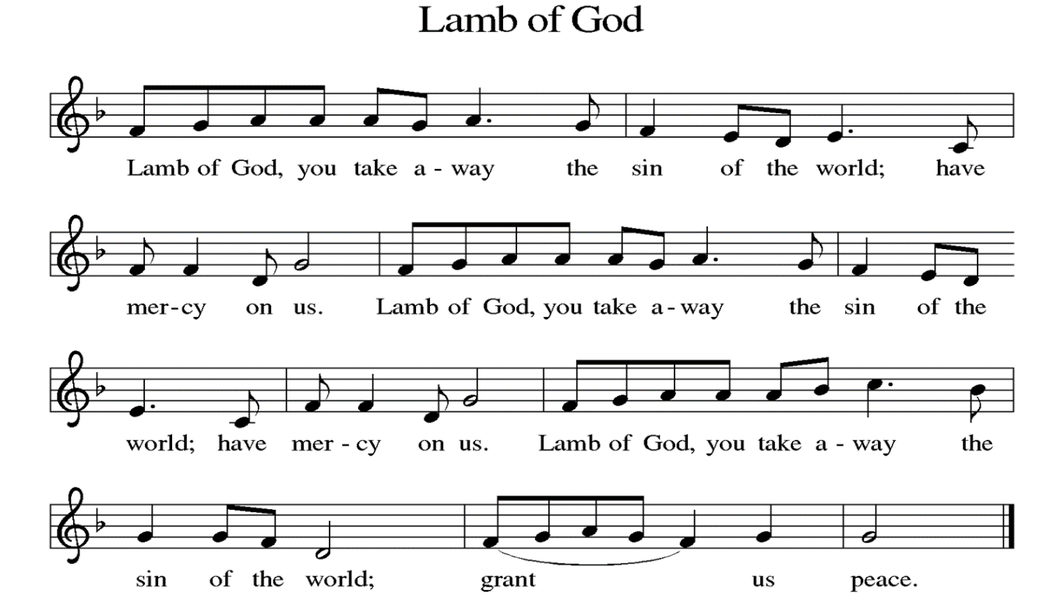

**THE GREAT THANKSGIVING**

P: The Lord be with you.

**C: And also with you.**

P: Lift up your hearts.

**C: We lift them to the Lord.**

P: Let us give thanks to the Lord our God.

**C: It is right to give our thanks and praise. Hosanna in the highest!**

In the night in which he was betrayed, our Lord Jesus took bread, and gave thanks; broke it, and gave it to his disciples, saying: Take and eat; this is my body, given for you. Do this for the remembrance of me.

Again, after supper, he took the cup, gave thanks, and gave it for all to drink, saying: This cup is the new covenant in my blood, shed for you and for all people for the forgiveness of sin. Do this for the remembrance of me.

For as often as we eat of this bread and drink from this cup, we proclaim the Lord's death until He comes. **C:** **Amen.**

**LORD’S PRAYER**

P: Remember us and teach us to pray,

**C: Our Father, who art in heaven, hallowed be thy name, thy kingdom come, thy will be done, on earth as it is in heaven. Give us this day our daily bread; and forgive us our trespasses, as we forgive those who trespass against us; and lead us not into temptation, but deliver us from evil. For thine is the kingdom, and the power, and the glory, forever and ever. Amen.**

**INVITATION TO COMMUNION**

P: The risen Christ is made known to us in the breaking of the bread. Come and eat at God’s table. **C: Amen.**

**DISTRIBUTION** *Time is given for the sharing of bread and wine. Additional verbal directions*

*will be given.*

**DISTRIBUTION** **HYMNS** “O Christ, Our Light ” ELW#675

**COMMUNION BLESSING**

P: The body and blood of our Lord Jesus Christ strengthen you in God’s grace unto eternal life.

**C: Amen.**

**PRAYER**

L: Shepherding God, you have prepared a table before us and nourished us with your love. Send us forth from this banquet to proclaim your goodness and share the abundant mercy of Jesus, our redeemer and friend. **C: Amen.**

**BENEDICTION**

P: The Lord bless you and keep you; the Lord’s face shine upon you and be gracious to you; the Lord look upon you with favor and give you peace. **Amen.** *(Num. 6:24)*

**SENDING HYMN** “Oh For a Thousand Tongues” ELW#886

**DISMISSAL**

L: Alleluia! Go in peace. Rejoice and be glad.

**C: Thanks be to God. Alleluia!**

**POSTLUDE**  “Prayer for Peach” Colin Curtis

**ANNOUNCEMENTS**

**This Week at LCLC**

Sunday (9-15) 8:00 AM Vocal Choir

9:15 AM Worship

10:30 AM Adult Ed

12:00 PM God’s Work Our Hands - Blessing and Sending gathering at Good Shepherd

Monday (9-16) 6:00 PM CVT

7:00 PM Council

Tuesday (9-17) 10:00 AM Bible Study – Exodus (Great Room)

11:00 AM Exercise Class

Thursday (9-19) 11:00 AM Exercise Class

11:30 AM Lunch Bunch

6:00 AM Bells Practice

Saturday (9-21) 9:00 AM Girl Scouts

1. **GOD’S WORK OUR HANDS SUNDAY, TODAY September 8th** with Great Rivers Collaborative - Beginning at **12 PM** at Good Shepherd Lutheran Church. We will gather for a blessing and sending before engaging in service opportunities with partner churches.
2. **SHEPHERD OF THE HILLS** would like to invite GRC members to join the Wednesday Zoom Bible Study led by Pr. Karen Scherer. This group meets weekly via Zoom from 9:30-11:00 am. Beginning **Wednesday, September 11**, they will look at the shortest letter in the New Testament: Philemon. After that study, the group will decided together what they’d like to study next. Contact Pr. Karen Scherer at karenscherer61@yahoo.com for the Zoom link, or to ask more questions.
3. **VOCAL CHOIR** **September 15 at 8am.**
4. **CELEBRATE FALL** with a mum for your deck, patio, porch, a friend, etc. Fill out a form and return it with your payment by **September 15**. Checks should be made out to Living Christ and indicate Mums in the memo line.
5. **FIFTY PLUS** **SEPTEMBER OUTING** is planning an outing on **September 18** at 10:00 am at the Powder Valley Conservation Center at 11715 Cragwold Rd. Kirkwood, Mo. There are paved trails, accessible educational nature center, aquarium, educational exhibits and gift shop. Lunch will follow at PJ’S Tavern in Kirkwood. A sign-up sheet and directions are posted on the bulletin board.

**SEPTEMBER 8, 2024** Preaching/Presiding: Pr. Matt Assisting Minister: Randy Henning Lector: Angela Bennett Live Streaming: Rod Wallace Musician: Greg Ott Ushers: Glenn Albers & Ann Schultz Greeter: Jim Stoehner Altar Guild: Joyce Wolf & Ann Schultz

**SEPTEMBER 15, 2024** Preaching/Presiding: Pr. Matt Assisting Minister: Angela Bennett Lector: RandyHenning Live Streaming: Erle Craig Musician: David Eggers Ushers: Levaughn & Sheila Smart Greeter: Jann Mueller Altar Guild: Doris Stoehner, Bill Kaeppel & Marilyn Wiley