### **19th Sunday after Pentecost**

# 

**Sunday, September 29, 2024**

Lutheran Church of the Living Christ

2725 Concord Drive

Florissant, MO 63033

**PRELUDE** “Reflections on Woodworth” arr. Hugh S. Livingston Jr.

**WELCOME & ANNOUNCEMENTS** *(Details are on the slides and at the end of bulletin)*

**CONFESSION AND FORGIVENESS**

Blessed be the holy Trinity, ☩ one God, the God of manna, the God of miracles, the God of mercy.

**Amen.**

Drawn to Christ and seeking God’s abundance, let us confess our sin.

*Silence is kept for reflection.*

God, our provider,

**help us. We struggle to believe there is enough to share. We question your ways when they differ from the ways of the world in which we live. We turn to our own understanding rather than trusting in you. We take offense at your teachings and your ways. Turn us again to you. Where else can we turn? Share with us the words of eternal life and feed us for life in the world. Amen.**

Beloved people of God: in Jesus, the manna from heaven, you are fed and nourished. By Jesus, the worker of miracles, there is always more than enough. Through Jesus, ☩ the bread of life, you are shown God’s mercy: you are forgiven and loved into abundant life. Amen.

**GATHERING HYMN** “Gather Us In” ELW#532

**GREETING**

P: Beloved of God, called to be saints: Grace, mercy, and peace be with you all.

**C: And also with you.**

**PRAYER OF THE DAY**

Generous God, your Son gave his life that we might come to peace with you. Give us a share of your Spirit, and in all we do empower us to bear the name of Jesus Christ, our Savior and Lord.

**Amen.**

**CHOIR ANTHEM** God is Calling Us

*Please be seated.*

**FIRST READING Numbers 11:4-6, 10-16, 24-29**

4The rabble among them had a strong craving; and the Israelites also wept again, and said, “If only we had meat to eat! 5We remember the fish we used to eat in Egypt for nothing, the cucumbers, the melons, the leeks, the onions, and the garlic; 6but now our strength is dried up, and there is nothing at all but this manna to look at.”

10Moses heard the people weeping throughout their families, all at the entrances of their tents. Then the Lord became very angry, and Moses was displeased. 11So Moses said to the Lord, “Why have you treated your servant so badly? Why have I not found favor in your sight, that you lay the burden of all this people on me? 12Did I conceive all this people? Did I give birth to them, that you should say to me, ‘Carry them in your bosom, as a nurse carries a sucking child, to the land that you promised on oath to their ancestors’? 13Where am I to get meat to give to all this people? For they come weeping to me and say, ‘Give us meat to eat!’ 14I am not able to carry all this people alone, for they are too heavy for me. 15If this is the way you are going to treat me, put me to death at once—if I have found favor in your sight—and do not let me see my misery.”

16So the Lord said to Moses, “Gather for me seventy of the elders of Israel, whom you know to be the elders of the people and officers over them; bring them to the tent of meeting, and have them take their place there with you.”

24So Moses went out and told the people the words of the Lord; and he gathered seventy elders of the people, and placed them all around the tent. 25Then the Lord came down in the cloud and spoke to him, and took some of the spirit that was on him and put it on the seventy elders; and when the spirit rested upon them, they prophesied. But they did not do so again.

26Two men remained in the camp, one named Eldad, and the other named Medad, and the spirit rested on them; they were among those registered, but they had not gone out to the tent, and so they prophesied in the camp. 27And a young man ran and told Moses, “Eldad and Medad are prophesying in the camp.” 28And Joshua son of Nun, the assistant of Moses, one of his chosen men, said, “My lord Moses, stop them!” 29But Moses said to him, “Are you jealous for my sake? Would that all the Lord’s people were prophets, and that the Lord would put his spirit on them!”

L: Word of God, Word of Life **C: Thanks be to God.**

### **Psalm 19:7-14**

### L: The teaching of the Lord is perfect and revives the soul;

### the testimony of the Lord is sure and gives wisdom to the simple.

### C: **The statutes of the Lord are just and rejoice the heart;**

### **the commandment of the Lord is clear and gives light to the eyes.**

### L: The fear of the Lord is clean and endures forever;

### the judgments of the Lord are true and righteousaltogether.

### C: **More to be desired are they than gold, more than much fine gold,**

### **sweeter far than honey, than honey in the comb.**

### L: By them also is your servant enlightened,

### and in keeping them there is great reward.

### C: **Who can detect one’s own offenses?**

### **Cleanse me from my secret faults.**

### L: Above all, keep your servant from presumptuous sins; let them not get dominion over me;

### then shall I be whole and sound, and innocent of a great offense.

### C: **Let the words of my mouth and the meditation of my heart be acceptable in your sight,**

### **O Lord, my strength and my redeemer.**

**SECOND READING James 5:13-20**

13Are any among you suffering? They should pray. Are any cheerful? They should sing songs of praise. 14Are any among you sick? They should call for the elders of the church and have them pray over them, anointing them with oil in the name of the Lord. 15The prayer of faith will save the sick, and the Lord will raise them up; and anyone who has committed sins will be forgiven. 16Therefore confess your sins to one another, and pray for one another, so that you may be healed. The prayer of the righteous is powerful and effective. 17Elijah was a human being like us, and he prayed fervently that it might not rain, and for three years and six months it did not rain on the earth. 18Then he prayed again, and the heaven gave rain and the earth yielded its harvest.

19My brothers and sisters, if anyone among you wanders from the truth and is brought back by another, 20you should know that whoever brings back a sinner from wandering will save the sinner’s soul from death and will cover a multitude of sins.

L: Word of God, Word of life. **C: Thanks be to God.**

**GOSPEL READING** - *Please stand, as you are able, to welcome the gospel.*

P: The holy Gospel according to **Mark, the 9th chapter (verses 38-50)**

**C: Glory to you, O Lord.**

38John said to [Jesus], “Teacher, we saw someone casting out demons in your name, and we tried to stop him, because he was not following us.” 39But Jesus said, “Do not stop him; for no one who does a deed of power in my name will be able soon afterward to speak evil of me. 40Whoever is not against us is for us. 41For truly I tell you, whoever gives you a cup of water to drink because you bear the name of Christ will by no means lose the reward.

42“If any of you put a stumbling block before one of these little ones who believe in me, it would be better for you if a great millstone were hung around your neck and you were thrown into the sea. 43If your hand causes you to stumble, cut it off; it is better for you to enter life maimed than to have two hands and to go to hell, to the unquenchable fire. 45And if your foot causes you to stumble, cut it off; it is better for you to enter life lame than to have two feet and to be thrown into hell. 47And if your eye causes you to stumble, tear it out; it is better for you to enter the kingdom of God with one eye than to have two eyes and to be thrown into hell, 48where their worm never dies, and the fire is never quenched.

49“For everyone will be salted with fire. 50Salt is good; but if salt has lost its saltiness, how can you season it? Have salt in yourselves, and be at peace with one another.”

P: The Gospel of the Lord. **C: Praise to you, O Christ.**

*Following the reading the assembly is seated.*

**SERMON** Pastor Matt

**HYMN OF THE DAY** “All Creatures, Worship God Most High!” ELW#835

**PROFESSION OF FAITH –** *The Apostles’ Creed*

**I believe in God, the Father almighty,**

**creator of heaven and earth.**

**I believe in Jesus Christ, God’s only Son, our Lord,**

**who was conceived by the Holy Spirit,**

**born of the virgin Mary,**

**suffered under Pontius Pilate,**

**was crucified, died, and was buried;**

**he descended to the dead.\***

**On the third day he rose again;**

**he ascended into heaven,**

**he is seated at the right hand of the Father,**

**and he will come to judge the living and the dead.**

**I believe in the Holy Spirit,**

**the holy catholic church,**

**the communion of saints,**

**the forgiveness of sins,**

**the resurrection of the body,**

**and the life everlasting. Amen.**

*Please be seated.*

### 

### 

### **PRAYERS OF INTERCESSION**

Drawn together in the power of the Holy Spirit, we pray with confidence for the church, God’s good creation, and all who are in need.

*A brief silence*.

We pray for the people of God in all places. Shape our witness to the good news of Jesus that we joyfully share your transforming love with all whom we encounter. Hear us, O God.

**Your mercy is great.**

We pray for the healing of the earth. Renew oceans and seas, marshes and estuaries. Uphold the work of conservationists, oceanographers, and all who care for fragile ecosystems and habitats. Hear us, O God.

**Your mercy is great.**

We pray for peace and cooperation among local and global communities. Bless the efforts of community organizers, international aid workers, and all those who work for justice and peace around the world. Hear us, O God.

**Your mercy is great.**

We pray for all who are in any need. To all who grieve, bring consolation; to all who are weary or lonely, bring solace. By your grace, make your presence known among all who call to you for healing (*especially*). Hear us, O God.

**Your mercy is great.**

We pray for caregivers: doctors and nurses, home health aides and counselors, and those who care for loved ones (*other caregivers or individuals may be named*). Sustain them in their work and help us to build a health care system that supports all. Hear us, O God.

**Your mercy is great.**

*Here other intercessions may be offered.*

We give thanks for the saints who now rest in your eternal presence. In thanksgiving for their lives of faithful service and witness, we commend them to your loving care. Hear us, O God.

**Your mercy is great.**

God, creator of generations, you have worked through families to bring faith, hope, and love since creation. Continue to nurture, guide, and inspire our family of faith, especially our brothers and sisters in the Clifford, Craig, & Keeven families**.** Guide, protect, and build these families up in faith. Hear us, O God,

**Your mercy is great.**

We entrust these and all our prayers to you, holy God, in the name of your beloved child, Jesus Christ, our Savior.

**Amen.**

**MINISTRY SPOTLIGHT -** Our members joined folks from other Great Rivers Collaborative churches for God's Work Our Hands Sunday. Many projects were accomplished that day. Thank you for your gift of TIME.

*Please stand as you are able*

**SHARING OF THE PEACE**

P: The peace of Christ be with you always. **C: And also with you.**

*Share God’s peace in whatever way you are comfortable. Following this please be seated.*

**GATHERING OF OFFERINGS**

**OFFERING PRAYER**

P: Risen One, you call us to believe and bear fruit. May the gifts that we offer here be signs of your abiding love. Form us to be your witnesses in the world, through Jesus Christ, our true vine. **C: Amen.**

**THE GREAT THANKSGIVING**

P: The Lord be with you.

**C: And also with you.**

P: Lift up your hearts.

**C: We lift them to the Lord.**

P: Let us give thanks to the Lord our God.

**C: It is right to give our thanks and praise.**

P: It is indeed right, our duty and our joy, that we should at all times and in all places give thanks and praise to you, almighty and merciful God, through our Savior Jesus Christ; who on this day overcame death and the grave, and by his glorious resurrection opened to us the way of everlasting life. And so, with all the choirs of angels, with the church on earth and the hosts of heaven, we praise your name and join their unending hymn:

In the night in which he was betrayed, our Lord Jesus took bread, and gave thanks; broke it, and gave it to his disciples, saying: Take and eat; this is my body, given for you. Do this for the remembrance of me.

Again, after supper, he took the cup, gave thanks, and gave it for all to drink, saying: This cup is the new covenant in my blood, shed for you and for all people for the forgiveness of sin. Do this for the remembrance of me.

Remembering, therefore, his death, resurrection, and ascension, we await his coming in glory.

**C:** **Amen.**

**LORD’S PRAYER**

P: Remember us and teach us to pray,

**C: Our Father, who art in heaven, hallowed be thy name, thy kingdom come, thy will be done, on earth as it is in heaven. Give us this day our daily bread; and forgive us our trespasses, as we forgive those who trespass against us; and lead us not into temptation, but deliver us from evil. For thine is the kingdom, and the power, and the glory, forever and ever. Amen.**

**INVITATION TO COMMUNION**

P: The risen Christ is made known to us in the breaking of the bread. Come and eat at God’s table. **C: Amen.**

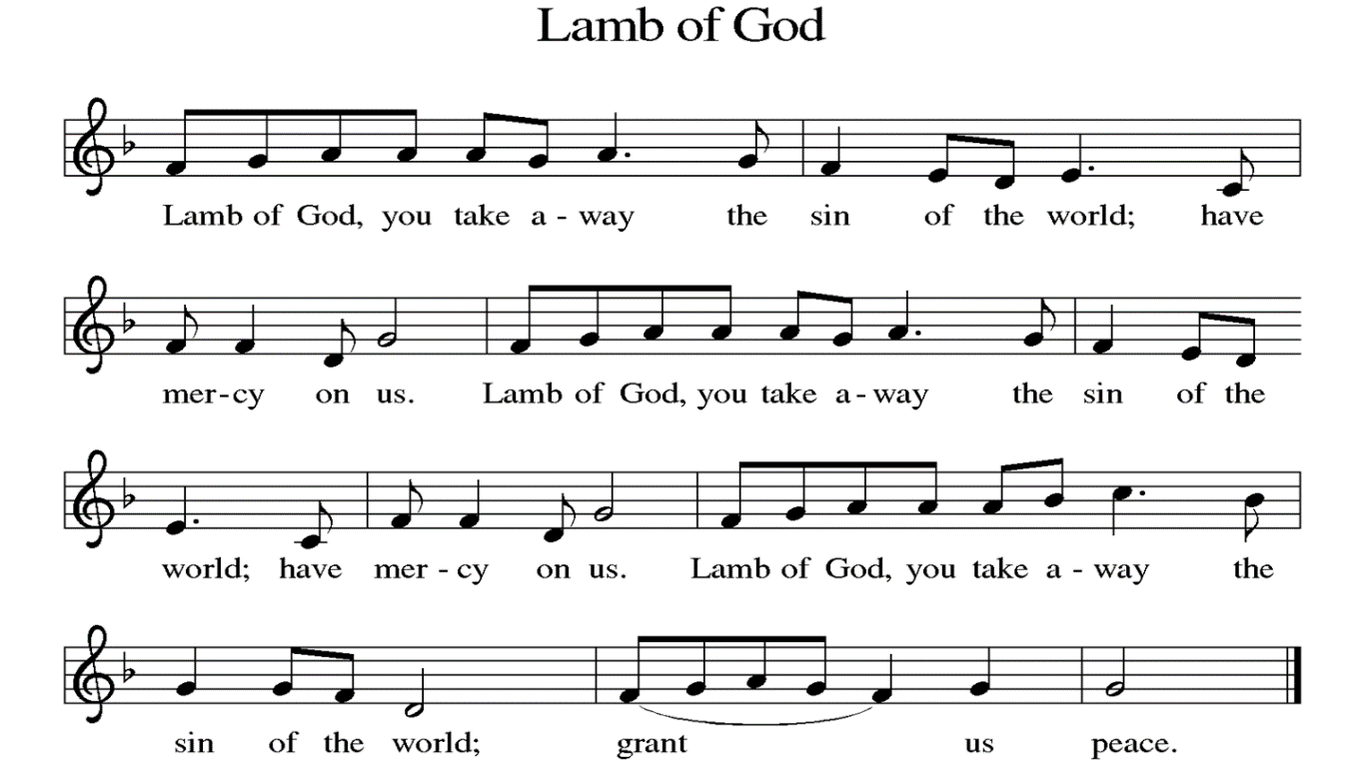

**DISTRIBUTION** *Time is given for the sharing of bread and wine. Additional verbal directions*

*will be given.*

**DISTRIBUTION** **HYMNS** “There is a Balm in Gilead” ELW#614

**COMMUNION BLESSING**

P: The body and blood of our Lord Jesus Christ strengthen you in God’s grace unto eternal life.

**C: Amen.**

**PRAYER**

L: Shepherding God, you have prepared a table before us and nourished us with your love. Send us forth from this banquet to proclaim your goodness and share the abundant mercy of Jesus, our redeemer and friend. **C: Amen.**

**BENEDICTION**

P: The Lord bless you and keep you; the Lord’s face shine upon you and be gracious to you; the Lord look upon you with favor and give you peace. **Amen.** *(Num. 6:24)*

**SENDING HYMN** “God Who Stretched” ELW#771

**DISMISSAL**

L: Alleluia! Go in peace. Rejoice and be glad.

**C: Thanks be to God. Alleluia!**

**POSTLUDE**  “Canticle of Praise” David Paxton

**ANNOUNCEMENTS**

**This Week at LCLC**

Sunday (9-29) 8:00 AM Vocal Choir

9:15 AM Worship

10:30 AM Adult Ed

Tuesday (10-1) 10:00 AM Bible Study – Acts (Great Room)

11:00 AM Exercise Class

6:30 PM Wedgewood HOA

Thursday (10-3) 11:00 AM Exercise Class

Friday (10-4) 11:00 AM Bells Practice

Saturday (10-5) 1:00 PM Blessing of the Animals

1. **BLESSING OF THE ANIMALS** on Saturday, October 5 @ 1pm. This is a public event open to all.
2. **WORSHIP WITH ZION** October 6 @ 9:30am. **WE WILL NOT NEED WORSHIP ASSISTANTS. OCTOBER LUNCH BUNCH** Lunch Bunch will be dining at Ferguson Brewery on **October 10** located at 418 S. Florissant Rd, Ferguson, MO at 11:30 am. Lunch bunch is a nice way to enjoy a meal and enjoy fellowship. We welcome everyone to attend. For reservations contact Joyce Meyer at 314-374-4135 or email @ **jameyer46@charter.net**
3. **FIFTY PLUS OKTOBERFEST!** Wednesday, **October 16** at 10:30 AM on the lower level. Fun time with trivia, games, and a German style meal of brats, sauerkraut, potato salad, desserts, beer, soda, and pretzels. Cost is $5 for members or $10 for non-members, sign up on the bulletin board, and pay at event. Everyone is welcome!
4. **COUNCIL WOMAN SHALONDA WEBB** will be here for a Wedgewood Meeting on Thursday, October 24 starting @ 6:30pm in the Upper Level.
5. **CANDY NEEDED** – Please help by donating large quantities of **single wrapped** candy for Trunk ‘r Treat on October 26. Place donations in the bucket under the table in the back of the great room.

**September 29, 2024**

**Preaching/Presiding: Pr. Matt**

**Assisting Minister: Randy Henning**

**Lector: Terry Calderwood**

**Live Streaming: Rod Wallace**

**Musician: Greg Ott**

**Ushers: Jim & Doris Stoehner**

**Greeter: Joyce Meyer**

**Altar Guild: Cathie Lehr & Joyce Meyer**

**October 6, 2024**

**Preaching/Presiding: Pr. Matt**

**Assisting Minister: Angela Bennett**

**Lector: Angela Bennett**

**Live Streaming: Erle Craig**

**Musician: David Eggers**

**Ushers: Gloria Broderick & Cathie Lehr**

**Greeter: Jeanne Calderwood**

**Altar Guild: Karen Haynes & Sheila Smart**