### **18th Sunday after Pentecost**

# 

**Sunday, September 22, 2024**

Lutheran Church of the Living Christ

2725 Concord Drive

Florissant, MO 63033

**PRELUDE** “Praise the One Who Breaks the Darkness” Paul Manz

**WELCOME & ANNOUNCEMENTS** *(Details are on the slides and at the end of bulletin)*

**CONFESSION AND FORGIVENESS**

Blessed be the holy Trinity, ☩ one God, the God of manna, the God of miracles, the God of mercy.

**Amen.**

Drawn to Christ and seeking God’s abundance, let us confess our sin.

*Silence is kept for reflection.*

God, our provider,

**help us. We struggle to believe there is enough to share. We question your ways when they differ from the ways of the world in which we live. We turn to our own understanding rather than trusting in you. We take offense at your teachings and your ways. Turn us again to you. Where else can we turn? Share with us the words of eternal life and feed us for life in the world. Amen.**

Beloved people of God: in Jesus, the manna from heaven, you are fed and nourished. By Jesus, the worker of miracles, there is always more than enough. Through Jesus, ☩ the bread of life, you are shown God’s mercy: you are forgiven and loved into abundant life. Amen.

**GATHERING HYMN** “Praise the One Who Breaks the Darkness” ELW#843

**GREETING**

P: Beloved of God, called to be saints: Grace, mercy, and peace be with you all.

**C: And also with you.**

**PRAYER OF THE DAY**

O God, our teacher and guide, you draw us to yourself and welcome us as beloved children. Help us to lay aside all envy and selfish ambition, that we may walk in your ways of wisdom and understanding as servants of your Son, Jesus Christ, our Savior and Lord.

**Amen.**

**SPECIAL MUSIC**

*Please be seated.*

**FIRST READING Jeremiah 11:18-20**

18It was the Lord who made it known to me, and I knew;then you showed me their evil deeds.  
 19But I was like a gentle lamb led to the slaughter. And I did not know it was against me  
  that they devised schemes, saying,“Let us destroy the tree with its fruit, let us cut him off from the land of the living, so that his name will no longer be remembered!” 20But you, O Lord of hosts, who judge righteously,  
  who try the heart and the mind, let me see your retribution upon them, for to you I have committed my cause.

L: Word of God, Word of Life **C: Thanks be to God.**

### 

### 

### **Psalm 54**

### L: 1Save me, O God, by your name; in your might, defend my cause.

### C: 2**Hear my prayer, O God; give ear to the words of my mouth.**

### L: 3For strangers have risen up against me, and the ruthless have sought my life,

### those who have no regard for God.

### C: 4**Behold, God | is my helper; it is the Lord who sustains my life.**

### L: 5Render evil to those who spy on me; in your faithfulness, destroy them.

### C: 6**I will offer you a freewill sacrifice and praise your name, O Lord, for it is good.**

### L: 7For you have rescued me from every trouble, and my eye looks down on my enemies.

### 

**SECOND READING James 3:13—4:3, 7-8a**

13Who is wise and understanding among you? Show by your good life that your works are done with gentleness born of wisdom. 14But if you have bitter envy and selfish ambition in your hearts, do not be boastful and false to the truth. 15Such wisdom does not come down from above, but is earthly, unspiritual, devilish. 16For where there is envy and selfish ambition, there will also be disorder and wickedness of every kind. 17But the wisdom from above is first pure, then peaceable, gentle, willing to yield, full of mercy and good fruits, without a trace of partiality or hypocrisy. 18And a harvest of righteousness is sown in peace for those who make peace.4:

4:1Those conflicts and disputes among you, where do they come from? Do they not come from your cravings that are at war within you? 2You want something and do not have it; so you commit murder. And you covet something and cannot obtain it; so you engage in disputes and conflicts. You do not have, because you do not ask. 3You ask and do not receive, because you ask wrongly, in order to spend what you get on your pleasures.

7Submit yourselves therefore to God. Resist the devil, and he will flee from you. 8aDraw near to God, and he will draw near to you.

L: Word of God, Word of life. **C: Thanks be to God.**

**GOSPEL READING** - *Please stand, as you are able, to welcome the gospel.*

P: The holy Gospel according to **Mark, the 9th chapter (verses 30-37)**

**C: Glory to you, O Lord.**

30[Jesus and the disciples went on] and passed through Galilee. He did not want anyone to know it;31for he was teaching his disciples, saying to them, “The Son of Man is to be betrayed into human hands, and they will kill him, and three days after being killed, he will rise again.” 32But they did not understand what he was saying and were afraid to ask him.

33Then they came to Capernaum; and when he was in the house he asked them, “What were you arguing about on the way?” 34But they were silent, for on the way they had argued with one another who was the greatest. 35He sat down, called the twelve, and said to them, “Whoever wants to be first must be last of all and servant of all.” 36Then he took a little child and put it among them; and taking it in his arms, he said to them, 37“Whoever welcomes one such child in my name welcomes me, and whoever welcomes me welcomes not me but the one who sent me.”

P: The Gospel of the Lord. **C: Praise to you, O Christ.**

*Following the reading the assembly is seated.*

**SERMON** Pastor Matt

**HYMN OF THE DAY** “Children of the Heavenly Father” ELW#781

**PROFESSION OF FAITH –** *The Apostles’ Creed*

**I believe in God, the Father almighty,**

**creator of heaven and earth.**

**I believe in Jesus Christ, God’s only Son, our Lord,**

**who was conceived by the Holy Spirit,**

**born of the virgin Mary,**

**suffered under Pontius Pilate,**

**was crucified, died, and was buried;**

**he descended to the dead.\***

**On the third day he rose again;**

**he ascended into heaven,**

**he is seated at the right hand of the Father,**

**and he will come to judge the living and the dead.**

**I believe in the Holy Spirit,**

**the holy catholic church,**

**the communion of saints,**

**the forgiveness of sins,**

**the resurrection of the body,**

**and the life everlasting. Amen.**

*Please be seated.*

### **PRAYERS OF INTERCESSION**

Drawn together in the power of the Holy Spirit, we pray with confidence for the church, God’s good creation, and all who are in need.

*A brief silence.*

Loving God, you welcome all at your table of grace. Instill in your church a spirit of humility and curiosity, that we embrace all who seek you. We pray especially for ministries of hospitality and faith formation (*specific ministries may be named*). Hear us, O God.

**Your mercy is great.**

Creating God, you shape the world so there is more than enough for all. Curb our habits of overuse, and guide us toward more sustainable sources of energy, food, and water. Hear us, O God.

**Your mercy is great.**

Gracious God, your peace brings justice and solidarity. Encourage peace among peoples, tribes, and nations; heal divisions in our country and local communities, that together we might cooperate for the good of all. Hear us, O God.

**Your mercy is great.**

Faithful God, you draw near to you all who are in need. Bring healing and wholeness to all who suffer (*especially*). Transform economic, political, and social systems that oppress vulnerable people, especially systems of structural racism and generational poverty. Hear us, O God.

**Your mercy is great.**

God, creator of generations, you have worked through families to bring faith, hope, and love since creation. Continue to nurture, guide, and inspire our family of faith, especially our brothers and sisters in the Enforf, Kaeppel & Tibbs families**.** Guide, protect, and build these families up in faith. Hear us, O God,

**Your mercy is great.**

Transforming God, you accompany all through changes and transitions. Help us to see where you are calling this community to new ways of living the gospel promise; assure us that even as change brings loss, it also brings hope and life. Hear us, O God.

**Your mercy is great.**

*Here other intercessions may be offered.*

Merciful God, you embrace us on our final pilgrimage from this life. Accompany all who have died, console those who mourn, and at the last, show us the way to eternal life in you. Hear us, O God.

**Your mercy is great.**

We entrust these and all our prayers to you, holy God, in the name of your beloved child, Jesus Christ, our Savior.

**Amen.**

**MINISTRY SPOTLIGHT -** Thank you to our Council Members who dedicate a good bit of TIME, attending meetings, preparing reports, and volunteering in many capacities.

*Please stand as you are able*

**SHARING OF THE PEACE**

P: The peace of Christ be with you always. **C: And also with you.**

*Share God’s peace in whatever way you are comfortable. Following this please be seated.*

**GATHERING OF OFFERINGS**

**OFFERING PRAYER**

P: Risen One, you call us to believe and bear fruit. May the gifts that we offer here be signs of your abiding love. Form us to be your witnesses in the world, through Jesus Christ, our true vine. **C: Amen.**

**THE GREAT THANKSGIVING**

P: The Lord be with you.

**C: And also with you.**

P: Lift up your hearts.

**C: We lift them to the Lord.**

P: Let us give thanks to the Lord our God.

**C: It is right to give our thanks and praise. Hosanna in the highest!**

In the night in which he was betrayed, our Lord Jesus took bread, and gave thanks; broke it, and gave it to his disciples, saying: Take and eat; this is my body, given for you. Do this for the remembrance of me.

Again, after supper, he took the cup, gave thanks, and gave it for all to drink, saying: This cup is the new covenant in my blood, shed for you and for all people for the forgiveness of sin. Do this for the remembrance of me.

For as often as we eat of this bread and drink from this cup, we proclaim the Lord's death until He comes. **C:** **Amen.**

**LORD’S PRAYER**

P: Remember us and teach us to pray,

**C: Our Father, who art in heaven, hallowed be thy name, thy kingdom come, thy will be done, on earth as it is in heaven. Give us this day our daily bread; and forgive us our trespasses, as we forgive those who trespass against us; and lead us not into temptation, but deliver us from evil. For thine is the kingdom, and the power, and the glory, forever and ever. Amen.**

**INVITATION TO COMMUNION**

P: The risen Christ is made known to us in the breaking of the bread. Come and eat at God’s table. **C: Amen.**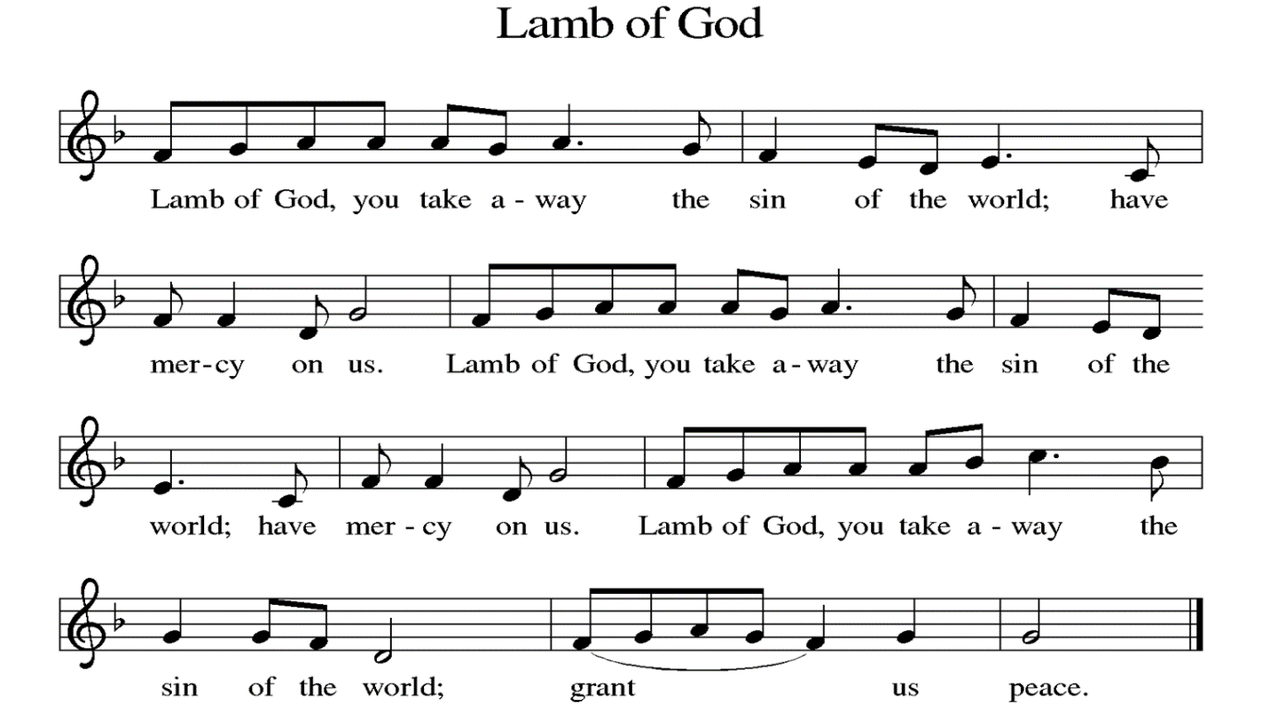

**DISTRIBUTION** *Time is given for the sharing of bread and wine. Additional verbal directions*

*will be given.*

**DISTRIBUTION** **HYMNS** “Jesus Loves Me” ELW#595

**COMMUNION BLESSING**

P: The body and blood of our Lord Jesus Christ strengthen you in God’s grace unto eternal life.

**C: Amen.**

**PRAYER**

L: Shepherding God, you have prepared a table before us and nourished us with your love. Send us forth from this banquet to proclaim your goodness and share the abundant mercy of Jesus, our redeemer and friend. **C: Amen.**

**BENEDICTION**

P: The Lord bless you and keep you; the Lord’s face shine upon you and be gracious to you; the Lord look upon you with favor and give you peace. **Amen.** *(Num. 6:24)*

**SENDING HYMN** “I Want to Walk” ELW#815

**DISMISSAL**

L: Alleluia! Go in peace. Rejoice and be glad.

**C: Thanks be to God. Alleluia!**

**POSTLUDE**

**ANNOUNCEMENTS**

**This Week at LCLC**

Sunday (9-22) 8:00 AM Vocal Choir

9:15 AM Worship

10:30 AM Adult Ed

11:00 AM True Vine

4:00 PM Fox Lake Meeting

Tuesday (9-24) 10:00 AM Bible Study – Exodus (Great Room)

11:00 AM Exercise Class

3:00 PM Strategy Meeting

Wednesday (9-25) 6:00 PM Trunk or Treat Meeting

Thursday (9-26) 11:00 AM Exercise Class

6:00 PM Bells Practice

Saturday (9-28) 10:00 AM Beverly Albers Memorial Service

1. **FALL begins today. Your mums are ready for pickup today after worship.**
2. **Trunk or Treat meeting** Wednesday, Sept 25 6:00 pm
3. **Bev Albers Memorial Service September 28** 10am Visitation, 11am Memorial Service, Luncheon to follow
4. **MARK YOUR CALENDAR: Blessing of the Animals** on Saturday, October 5 @ 1pm. This is a public event open to all.
5. **Worship with Zion** October 6
6. **Council woman Shalonda Webb** will be here for a Wedgewood Meeting on Thursday, October 24 starting @ 6:30pm in the Upper Level.

**SEPTEMBER 22, 2024**

**Preaching/Presiding: Pr. Matt**

**Assisting Minister: Bill Kaeppel**

**Lector: Bill Kaeppel**

**Live Streaming: Gary & Laurie Brown**

**Musician: David Eggers**

**Ushers: Dave Endorf & Randy Henning**

**Greeter: Marilyn Wiley**

**Altar Guild: Maureen Buchek & Marjorie Becker**

**September 29, 2024**

**Preaching/Presiding: Pr. Matt**

**Assisting Minister: Randy Henning**

**Lector: Terry Calderwood**

**Live Streaming: Rod Wallace**

**Musician: Greg Ott**

**Ushers: Jim & Doris Stoehner**

**Greeter: Joyce Meyer**

**Altar Guild: Cathie Lehr & Joyce Meyer**