### **17th Sunday after Pentecost**

# 

**Sunday, September 15, 2024**

Lutheran Church of the Living Christ

2725 Concord Drive

Florissant, MO 63033

**PRELUDE** “Lift High the Cross” Paul Manz

**WELCOME & ANNOUNCEMENTS** *(Details are on the slides and at the end of bulletin)*

**CONFESSION AND FORGIVENESS**

Blessed be the holy Trinity, ☩ one God, the God of manna, the God of miracles, the God of mercy.

**Amen.**

Drawn to Christ and seeking God’s abundance, let us confess our sin.

*Silence is kept for reflection.*

God, our provider,

**help us. We struggle to believe there is enough to share. We question your ways when they differ from the ways of the world in which we live. We turn to our own understanding rather than trusting in you. We take offense at your teachings and your ways. Turn us again to you. Where else can we turn? Share with us the words of eternal life and feed us for life in the world. Amen.**

Beloved people of God: in Jesus, the manna from heaven, you are fed and nourished. By Jesus, the worker of miracles, there is always more than enough. Through Jesus, ☩ the bread of life, you are shown God’s mercy: you are forgiven and loved into abundant life. Amen.

**GATHERING HYMN** “Lift High the Cross” ELW #660

**GREETING**

P: Beloved of God, called to be saints: Grace, mercy, and peace be with you all.

**C: And also with you.**

**PRAYER OF THE DAY**

O God, through suffering and rejection you bring forth our salvation, and by the glory of the cross you transform our lives. Grant that for the sake of the gospel we may turn from the lure of evil, take up our cross, and follow your Son, Jesus Christ, our Savior and Lord.

**Amen.**

**BELLS CHOIR**  "My Jesus, I love Thee

**TEMPLE TALK** - Doris Stoehner “*Time*”

*Please be seated.*

**FIRST READING Isaiah 50:4-9a**

4The Lord God has given me the tongue of a teacher, that I may know how to sustain the weary with a word. Morning by morning he wakens— wakens my ear to listen as those who are taught.

5The Lord God has opened my ear, and I was not rebellious, I did not turn backward.

6I gave my back to those who struck me, and my cheeks to those who pulled out the beard; I did not hide my face from insult and spitting.

7The Lord God helps me; therefore I have not been disgraced; therefore I have set my face like flint, and I know that I shall not be put to shame;

8he who vindicates me is near. Who will contend with me? Let us stand up together. Who are my adversaries? Let them confront me.

9aIt is the Lord God who helps me; who will declare me guilty?

L: Word of God, Word of Life **C: Thanks be to God.**

### **Psalm 116:1-9**

### L: I love the Lord, who has heard my voice, and listened to my supplication,

### **C: for the Lord has given ear to me whenever I called.**

### L: The cords of death entangled me; the anguish of the grave came upon me; I came to grief and sorrow.

### **C: Then I called upon the name of the Lord: “O Lord, I pray you, save my life.”**

### L: Gracious is the Lord and righteous; our God is full of compassion.

### **C: The Lord watches over the innocent; I was brought low, and God saved me.**

### L: Turn again to your rest, O my soul. for the Lord has dealt well with you.

### **C: For you have rescued my life from death, my eyes from tears, and my feet from stumbling;**

### L: I will walk in the presence of the Lord in the land of the living.

**SECOND READING James 3:1-12**

1Not many of you should become teachers, my brothers and sisters, for you know that we who teach will be judged with greater strictness. 2For all of us make many mistakes. Anyone who makes no mistakes in speaking is perfect, able to keep the whole body in check with a bridle. 3If we put bits into the mouths of horses to make them obey us, we guide their whole bodies. 4Or look at ships: though they are so large that it takes strong winds to drive them, yet they are guided by a very small rudder wherever the will of the pilot directs. 5So also the tongue is a small member, yet it boasts of great exploits.

How great a forest is set ablaze by a small fire! 6And the tongue is a fire. The tongue is placed among our members as a world of iniquity; it stains the whole body, sets on fire the cycle of nature, and is itself set on fire by hell. 7For every species of beast and bird, of reptile and sea creature, can be tamed and has been tamed by the human species, 8but no one can tame the tongue—a restless evil, full of deadly poison. 9With it we bless the Lord and Father, and with it we curse those who are made in the likeness of God. 10From the same mouth come blessing and cursing. My brothers and sisters, this ought not to be so. 11Does a spring pour forth from the same opening both fresh and brackish water? 12Can a fig tree, my brothers and sisters, yield olives, or a grapevine figs? No more can salt water yield fresh.

L: Word of God, Word of life. **C: Thanks be to God.**

**GOSPEL READING** - *Please stand, as you are able, to welcome the gospel.*

P: The holy Gospel according to **Mark, the 8th chapter (verses 27-38)**

**C: Glory to you, O Lord.**

27Jesus went on with his disciples to the villages of Caesarea Philippi; and on the way he asked his disciples, “Who do people say that I am?” 28And they answered him, “John the Baptist; and others, Elijah; and still others, one of the prophets.” 29He asked them, “But who do you say that I am?” Peter answered him, “You are the Messiah.” 30And he sternly ordered them not to tell anyone about him.

31Then he began to teach them that the Son of Man must undergo great suffering, and be rejected by the elders, the chief priests, and the scribes, and be killed, and after three days rise again. 32He said all this quite openly. And Peter took him aside and began to rebuke him. 33But turning and looking at his disciples, he rebuked Peter and said, “Get behind me, Satan! For you are setting your mind not on divine things but on human things.”

34He called the crowd with his disciples, and said to them, “If any want to become my followers, let them deny themselves and take up their cross and follow me. 35For those who want to save their life will lose it, and those who lose their life for my sake, and for the sake of the gospel, will save it. 36For what will it profit them to gain the whole world and forfeit their life? 37Indeed, what can they give in return for their life? 38Those who are ashamed of me and of my words in this adulterous and sinful generation, of them the Son of Man will also be ashamed when he comes in the glory of his Father with the holy angels.”

P: The Gospel of the Lord. **C: Praise to you, O Christ.**

*Following the reading the assembly is seated.*

**SERMON** Pastor Matt

**HYMN OF THE DAY** “Let Us Ever Walk with Jesus” ELW#802

**PROFESSION OF FAITH –** *The Apostles’ Creed*

**I believe in God, the Father almighty,**

**creator of heaven and earth.**

**I believe in Jesus Christ, God’s only Son, our Lord,**

**who was conceived by the Holy Spirit,**

**born of the virgin Mary,**

**suffered under Pontius Pilate,**

**was crucified, died, and was buried;**

**he descended to the dead.\***

**On the third day he rose again;**

**he ascended into heaven,**

**he is seated at the right hand of the Father,**

**and he will come to judge the living and the dead.**

**I believe in the Holy Spirit,**

**the holy catholic church,**

**the communion of saints,**

**the forgiveness of sins,**

**the resurrection of the body,**

**and the life everlasting. Amen.**

*Please be seated.*

### **PRAYERS OF INTERCESSION**

Drawn together in the power of the Holy Spirit, we pray with confidence for the church, God’s good creation, and all who are in need.

*A brief silence.*

We pray for the church throughout the world. Form us into communities of forgiveness and grace. Help us to notice where you are calling us into new relationships and give us courage to embrace the uncomfortable and unfamiliar. Hear us, O God.

**Your mercy is great.**

We pray for the earth and all its inhabitants. Protect lands at risk of wildfire and heal dying forests. Where fire brings destruction, raise up new growth. Guide us in tending precarious ecosystems. Hear us, O God.

**Your mercy is great.**

We pray for those who govern nations, tribes, and cities. Open them to the cries of people in need. Direct them in shaping policies that prioritize the health and well-being of all who struggle with hunger and housing insecurity. Hear us, O God.

**Your mercy is great.**

We pray for all who are ill, all who are lonely or anxious, and all who grieve (*especially*). Draw them close to you and soothe them with the promise of your enduring love. Hear us, O God.

**Your mercy is great.**

We pray for teachers, professors, librarians, school administrators, staff, and all who support the education of young people. Sustain them as they shape learning communities, rooted in equity and authenticity. We pray for children of all ages in their learning. Hear us, O God.

**Your mercy is great.**

*Here other intercessions may be offered.*

We remember our dearly departed (*especially*), who with the great cloud of witnesses, bear witness to your saving grace. Accompany us in our journey of faith, that we too place our hope and trust in you. Hear us, O God.

**Your mercy is great.**

God, creator of generations, you have worked through families to bring faith, hope, and love since creation. Continue to nurture, guide, and inspire our family of faith, especially our brothers and sisters in the Buchek, Chappell, Mueller families**.** Guide, protect, and build these families up in faith. Hear us, O God,

**Your mercy is great**.

We entrust these and all our prayers to you, holy God, in the name of your beloved child, Jesus Christ, our Savior.

**Amen.**

**MINISTRY SPOTLIGHT -**The Car Show was a big success due to the TIME donated by car owners, Living Christ workers, and Girl Scouts. Thank you to all who were involved and to Karen Haynes for her organization of the event.

*Please stand as you are able*

**SHARING OF THE PEACE**

P: The peace of Christ be with you always. **C: And also with you.**

*Share God’s peace in whatever way you are comfortable. Following this please be seated.*

**GATHERING OF OFFERINGS**

**OFFERING PRAYER**

P: Risen One, you call us to believe and bear fruit. May the gifts that we offer here be signs of your abiding love. Form us to be your witnesses in the world, through Jesus Christ, our true vine. **C: Amen.**

**THE GREAT THANKSGIVING**

P: The Lord be with you.

**C: And also with you.**

P: Lift up your hearts.

**C: We lift them to the Lord.**

P: Let us give thanks to the Lord our God.

**C: It is right to give our thanks and praise. Hosanna in the highest!**

In the night in which he was betrayed, our Lord Jesus took bread, and gave thanks; broke it, and gave it to his disciples, saying: Take and eat; this is my body, given for you. Do this for the remembrance of me.

Again, after supper, he took the cup, gave thanks, and gave it for all to drink, saying: This cup is the new covenant in my blood, shed for you and for all people for the forgiveness of sin. Do this for the remembrance of me.

For as often as we eat of this bread and drink from this cup, we proclaim the Lord's death until He comes. **C:** **Amen.**

**LORD’S PRAYER**

P: Remember us and teach us to pray,

**C: Our Father, who art in heaven, hallowed be thy name, thy kingdom come, thy will be done, on earth as it is in heaven. Give us this day our daily bread; and forgive us our trespasses, as we forgive those who trespass against us; and lead us not into temptation, but deliver us from evil. For thine is the kingdom, and the power, and the glory, forever and ever. Amen.**

**INVITATION TO COMMUNION**

P: The risen Christ is made known to us in the breaking of the bread. Come and eat at God’s table. **C: Amen.**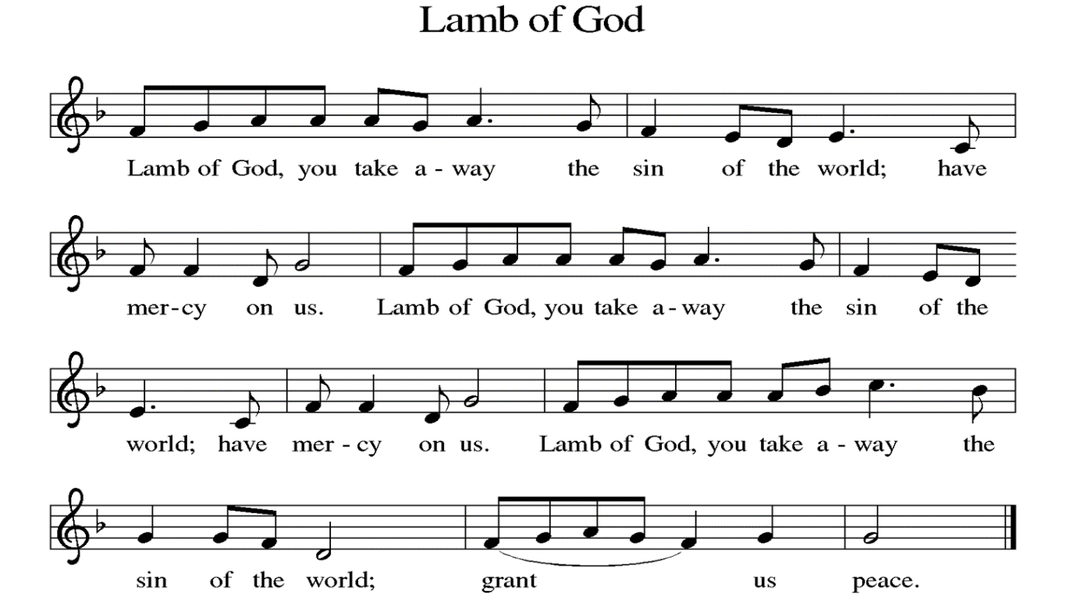

**DISTRIBUTION** *Time is given for the sharing of bread and wine. Additional verbal directions*

*will be given.*

**DISTRIBUTION** **HYMNS** “Will you Come and Follow ” ELW#798

**COMMUNION BLESSING**

P: The body and blood of our Lord Jesus Christ strengthen you in God’s grace unto eternal life.

**C: Amen.**

**PRAYER**

L: Shepherding God, you have prepared a table before us and nourished us with your love. Send us forth from this banquet to proclaim your goodness and share the abundant mercy of Jesus, our redeemer and friend. **C: Amen.**

**BENEDICTION**

P: The Lord bless you and keep you; the Lord’s face shine upon you and be gracious to you; the Lord look upon you with favor and give you peace. **Amen.** *(Num. 6:24)*

**SENDING HYMN** “Leaning on the Everlasting Arms” ELW#774

**DISMISSAL**

L: Alleluia! Go in peace. Rejoice and be glad.

**C: Thanks be to God. Alleluia!**

**POSTLUDE**   “ Let Us Ever Walk with Jesus” Richard Hillert

**ANNOUNCEMENTS**

**This Week at LCLC**

Sunday (9-15) 8:00 AM Vocal Choir

9:15 AM Worship

10:30 AM Adult Ed

Tuesday (9-17) 10:00 AM Bible Study – Exodus (Great Room)

11:00 AM Exercise Class

2:00 PM Worship Committee

Thursday (9-19) 11:00 AM Exercise Class

6:00 PM Bells Practice

1. **CELEBRATE FALL** with a mum for your deck, patio, porch, a friend, etc. Fill out a form and return it with your payment by **today**. Checks should be made out to Living Christ and indicate Mums in the memo line.
2. **FIFTY PLUS SEPTEMBER OUTING** is planning an outing on **September 18 at 10 AM** at the Powder Valley Conservation Center, 11715 Cragwold Rd. Kirkwood, Mo. There are paved trails, accessible educational nature center, aquarium, educational exhibits and gift shop. Lunch will follow at PJ’S Tavern in Kirkwood. A sign-up sheet and directions are posted on the bulletin board.
3. **Council Woman Shalonda Webb** will be here for a Wedgewood Meeting on Thursday, October 24 starting @ 6:30pm in the Upper Level.
4. **MARK YOUR CALENDAR: Blessing of the Animals** on Saturday, October 5 @ 1pm. This is a public event open to all.

**SEPTEMBER 15, 2024 Preaching/Presiding: Pr. Matt Assisting Minister: Angela Bennett Lector: Randy Henning Live Streaming: Erle Craig Musician: David Eggers Ushers: Levaughn & Sheila Smart Greeter: Jann Mueller Altar Guild: Doris Stoehner, Bill Kaeppel & Marilyn Wiley**

**SEPTEMBER 22, 2024**

**Preaching/Presiding: Pr. Matt**

**Assisting Minister: Bill Kaeppel**

**Lector: Bill Kaeppel**

**Live Streaming: Gary & Laurie Brown**

**Musician: David Eggers**

**Ushers: Dave Endorf & Randy Henning**

**Greeter: Marilyn Wiley**

**Altar Guild: Maureen Buchek & Marjorie Becker**