Sixth Sunday of Epiphany February 12th, 2023
9:15am - Hybrid Worship
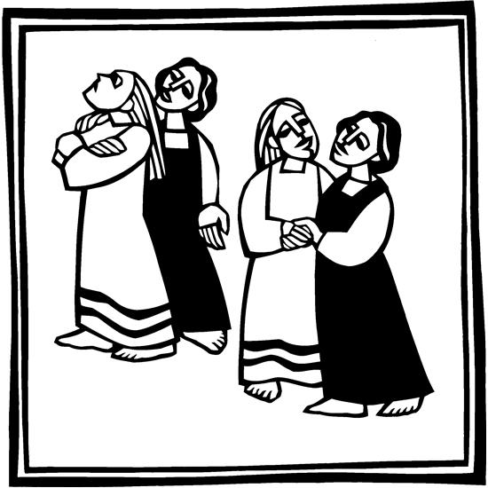
Lutheran Church of the Living Christ
2725 Concord Dr, Florissant, MO 63033
Find us online: www.lc-livingchrist.org

The Word has been made real flesh. We are constantly reminded of Jesus’ very real humanity throughout scripture: “who, though he existed in the form of God, did not regard equality with God as something to be grasped, but emptied himself, taking the form of a slave, assuming human likeness.” (Phil. 2:6-7).
We remember also how God chooses to dwell not in halls of power, but is born as a baby in an ordinary village. The Divine Presence dwells where we least expect it. For those who awaken to the true promise of the divine, a different way will be taken…sending us out in ways we least expect, by other roads.
Welcome to Lutheran Church of the Living Christ
Welcome! If you came as a guest today, we hope you leave as a friend. May this worship service surround you with the love of God through Christ and fill you with the Holy Spirit.
Invitation to Communion: We welcome all to commune at LCLC. It is not our table, nor this congregation’s table, nor our denomination’s table. It is the table of Jesus Christ. By his invitation there is a place for everyone. We believe that Jesus is present in the bread and wine that forgives sin, nourishes faith, and calls us to be witnesses to the gospel.
Notes about our worship service: Guidance is printed in italics throughout. “P” indicates the speaking part of the presiding minister; “L” indicates a speaking part of a lay leader; “C” and parts in boldface indicate speaking parts of the whole congregation. You may also follow along with the service by looking at the screen in the front of the sanctuary. Liturgical pieces are set to familiar Christmas tunes. This liturgy is provided by the Eastern Missouri Conference of the Central States Synod.
Please be mindful of others’ comfort with touch. Ask before giving a handshake or hug.
PRELUDE “Romanza” Anton Rubinstein

WELCOME

Confession and Forgiveness

All may make the sign of the cross, the sign that is marked at baptism, as the presiding minister begins.

P: Blessed be the holy Trinity, ☩ one God, who makes all things new, whose mercy endures forever.

C: Amen.

Trusting in God’s mercy, let us confess our sin.

Silence is kept for reflection.

P: Holy One, source of our renewal, C: we confess that we are wrapped up in sin, and cannot free ourselves. We have not practiced your righteousness. Our hearts have turned away from you. For the sake of the world you so love, forgive us, that we may be reconciled to one another for the glory of your holy name. Amen.

P: Thus says our God: C: “The former things have come to pass and new things I now declare.” God’s mercy makes us new. We are forgiven in the name of ☩ Christ our Savior. Amen.

GATHERING HYMN Holy Spirit, Ever Dwelling ELW #582

GREETING
P: The grace of our Lord Jesus Christ, the love of God,
and the communion of the Holy Spirit be with you all.
C: And also with you.

Prayer of the Day
O God, the strength of all who hope in you, because we are weak mortals we accomplish nothing good without you. Help us to see and understand the things we ought to do, and give us grace and power to do them, through Jesus Christ, our Savior and Lord.
Amen.

The assembly is seated.

First Reading: Deuteronomy 30:15-20

The Lord sets before the people of God a clear choice. Life and prosperity will come to the faithful; loss of the land will be the consequence of disobedience. Choosing life entails loving and holding fast to the Lord. Life in God’s presence presupposes the promise made to the ancestors. Moses said to the people:] ¹⁵See, I have set before you today life and prosperity, death and adversity. ¹⁶If you obey the commandments of the Lord your God that I am commanding you today, by loving the Lord your God, walking in his ways, and observing his commandments, decrees, and ordinances, then you shall live and become numerous, and the Lord your God will bless you in the land that you are entering to possess. ¹⁷But if your heart turns away and you do not hear, but are led astray to bow down to other gods and serve them, ¹⁸I declare to you today that you shall perish; you shall not live long in the land that you are crossing the Jordan to enter and possess. ¹⁹I call heaven and earth to witness against you today that I have set before you life and death, blessings and curses. Choose life so that you and your descendants may live, ²⁰loving the Lord your God, obeying him, and holding fast to him; for that means life to you and length of days, so that you may live in the land that the Lord swore to give to your ancestors, to Abraham, to Isaac, and to Jacob.

L: The Word of God still speaks.
C: Thanks be to God.

Choir Anthem: Send Us Forth

Psalm: Psalm 119:1-8

Happy are they who follow the teaching of the Lord. (Ps. 119:1)

L: Happy are they whose way is blameless, who follow the teaching of the Lord! C: Happy are they who observe your decrees and seek you with all their hearts, L: who never do any wrong, but always walk | in your ways. C: You laid down your commandments, that we should fully keep them. L: Oh, that my ways were made so direct I might keep your statutes! C:Then I should not be put to shame, when I regard all your commandments. L: I will thank you with a true heart, when I have learned your righteous judgments. C: I will keep your statutes; do not utterly forsake me.

Second Reading:1 Corinthians 3:1-9 Human leaders in the church are not the ones who control ministry. Rather they are coworkers who belong to God, the one who truly controls and continuously empowers the ministry of the church. ¹Brothers and sisters, I could not speak to you as spiritual people, but rather as people of the flesh, as infants in Christ. ²I fed you with milk, not solid food, for you were not ready for solid food. Even now you are still not ready, ³for you are still of the flesh. For as long as there is jealousy and quarreling among you, are you not of the flesh, and behaving according to human inclinations? ⁴For when one says, “I belong to Paul,” and another, “I belong to Apollos,” are you not merely human? ⁵What then is Apollos? What is Paul? Servants through whom you came to believe, as the Lord assigned to each. ⁶I planted, Apollos watered, but God gave the growth. ⁷So neither the one who plants nor the one who waters is anything, but only God who gives the growth. ⁸The one who plants and the one who waters have a common purpose, and each will receive wages according to the labor of each. ⁹For we are God’s servants, working together; you are God’s field, God’s building.
L: The Word of God still speaks.
C: Thanks be to God.

The assembly stands to welcome the gospel.
GOSPEL ACCLAMATION 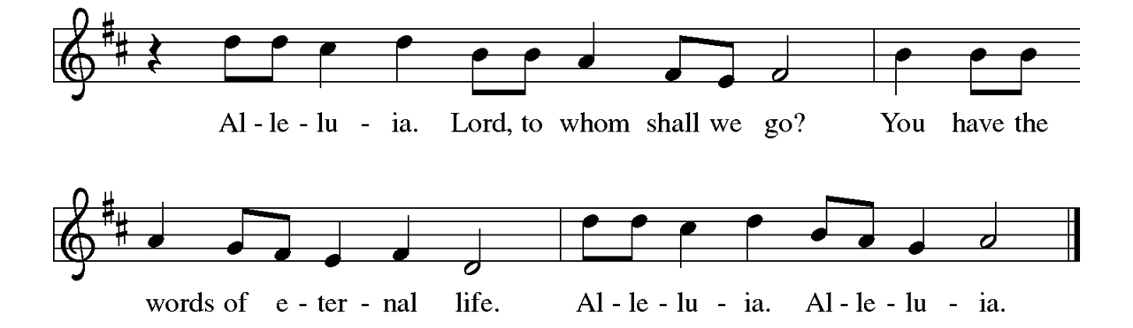

The Holy Gospel according to Matthew the 5th chapter Glory to you, O Lord.

In the Sermon on the Mount, Jesus exhorts his followers to embrace standards of righteousness that exceed legal requirements and traditional expectations. [Jesus said to the disciples:] ²¹“You have heard that it was said to those of ancient times, ‘You shall not murder’; and ‘whoever murders shall be liable to judgment.’ ²²But I say to you that if you are angry with a brother or sister, you will be liable to judgment; and if you insult a brother or sister, you will be liable to the council; and if you say, ‘You fool,’ you will be liable to the hell of fire. ²³So when you are offering your gift at the altar, if you remember that your brother or sister has something against you, ²⁴leave your gift there before the altar and go; first be reconciled to your brother or sister, and then come and offer your gift. ²⁵Come to terms quickly with your accuser while you are on the way to court with him, or your accuser may hand you over to the judge, and the judge to the guard, and you will be thrown into prison. ²⁶Truly I tell you, you will never get out until you have paid the last penny. ²⁷“You have heard that it was said, ‘You shall not commit adultery.’ ²⁸But I say to you that everyone who looks at a woman with lust has already committed adultery with her in his heart. ²⁹If your right eye causes you to sin, tear it out and throw it away; it is better for you to lose one of your members than for your whole body to be thrown into hell. ³⁰And if your right hand causes you to sin, cut it off and throw it away; it is better for you to lose one of your members than for your whole body to go into hell. ³¹“It was also said, ‘Whoever divorces his wife, let him give her a certificate of divorce.’ ³²But I say to you that anyone who divorces his wife, except on the ground of unchastity, causes her to commit adultery; and whoever marries a divorced woman commits adultery. ³³“Again, you have heard that it was said to those of ancient times, ‘You shall not swear falsely, but carry out the vows you have made to the Lord.’ ³⁴But I say to you, Do not swear at all, either by heaven, for it is the throne of God, ³⁵or by the earth, for it is his footstool, or by Jerusalem, for it is the city of the great King. ³⁶And do not swear by your head, for you cannot make one hair white or black. ³⁷Let your word be ‘Yes, Yes’ or ‘No, No’; anything more than this comes from the evil one.”
P: The Gospel of the Lord.
C: Praise to you, O Christ.
Following the reading the assembly is seated.

SERMON Pastor Matt Helfrich

INSTALLATION OF NEW COUNCIL MEMBERS
L: The following people have been elected to positions of leadership: Karen Haynes & Gary Schultz. We give thanks for their willingness to serve.
P: In baptism we are welcomed into the body of Christ and sent to share in the mission of God; we rejoice now that these sisters and brothers will lead your common life and your mutual mission as a congregation. You have been elected to positions of leadership and trust in this congregation. You are to see that the words and deeds of this household of faith bear witness to God, who gathers you into one together with the whole church. You are to seek to involve all members of this congregation in worship, learning, witness, service, and support, so that the mission of Christ is carried out in this congregation, in the wider church, in this community, and in the whole world. You are to be faithful in your specific area of serving, that the Spirit who empowers you may be glorified. You are to be examples of faith active in love, fostering peace, harmony, and mutual understanding in this congregation.
P: On behalf of your sisters and brothers in Christ, I ask you: Will you accept and faithfully carry out the duties of the offices to which you have been elected?
Response: I will, and I ask God to help me.
P: People of God, I ask you: Will you support these, your elected leaders, and will you share in the mutual ministry that Christ has given to all who are baptized?
C: We will, and we ask God to help us.
P: I now declare you installed as officers and council members of this congregation. Almighty God bless you, and direct your days and your deeds in peace, that you may be faithful servants of Christ.
C: Amen.The assembly is invited to stand.

HYMN OF THE DAY Healer of Our Every I11 ELW#612

Apostles’ Creed
I believe in God, the Father almighty, creator of heaven and earth. I believe in Jesus Christ, God's only Son, our Lord, who was conceived by the Holy Spirit, born of the virgin Mary, suffered under Pontius Pilate, was crucified, died, and was buried; he descended to the dead. On the third day he rose again; he ascended into heaven, he is seated at the right hand of the Father, and he will come to judge the living and the dead.
I believe in the Holy Spirit, the holy catholic church, the communion of saints, the forgiveness of sins, the resurrection of the body, and the life everlasting. Amen

Prayers of Intercession
Called together to follow Jesus, we pray for the church, the world, and all in need.
A brief silence.
Inspire your church that it may be a sign of life throughout the world. From the exploration of faith with children and new believers to missionaries and bishops, shape lives of faithfulness, so that all find abundant life in your ways. Merciful God,
receive our prayer.
Nourish your creation. Accompany all who plant and water. Bless the work of farmers; provide for subsistence farmers facing drought and climate change. Guide the work of agricultural scientists toward sustainable ways to feed the world. Merciful God,
receive our prayer.
Give growth where there seems to be no hope for life. In nations and regions where reconciliation seems impossible (especially), empower peacemakers with your Spirit. Where death holds sway through violence, disease, and hunger, equip relief workers to bring hope. Merciful God,
receive our prayer.
Nurture all in need (especially). Bring healing to all who experience trauma caused by systems of injustice and destructive relationships. Give courage to those struggling to repent and those seeking reconciliation. Sustain all who work for restoration (local restorative efforts may be named). Merciful God,
receive our prayer.
Encourage this congregation. Call us to a common purpose and keep us from quarrelling. Turn our hearts toward you and guide our leaders, so that our choices may be lifegiving for all. Merciful God,
receive our prayer.
Here other intercessions may be offered.
Thanks be to you for the lives of all who have died in Christ. Teach us to follow them in your ways and gather us with them into the promise of eternal life with you. Merciful God,
receive our prayer.
We bring to you our needs and hopes, O God, trusting your wisdom and power revealed in Christ crucified.
Amen.

SHARING OF THE PEACE
P: The peace of Christ be with you always.
C: And also with you.
Share a sign of peace by waving, flashing a peace sign, or another form of greeting.

Offering Prayer
Liberating God,
you break the bonds of injustice
and let the oppressed go free.
Receive these offerings in thanksgiving
for all your works of merciful power,
and shape us as people of your justice and freedom.
You we magnify and adore, through Jesus our Savior,
Amen.

COMMUNION LITURGY
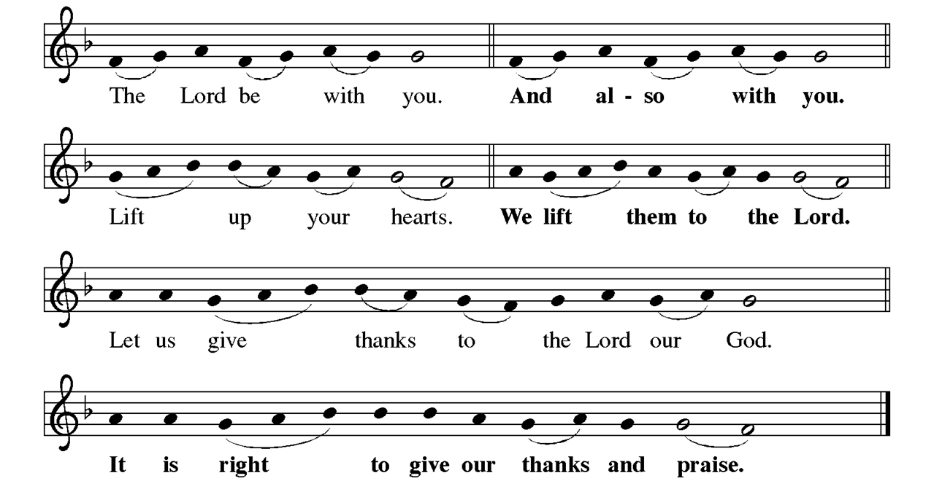
It is indeed right, our duty and our joy, that we should at all times and in all places give thanks and praise to you, almighty and merciful God, through our Savior Jesus Christ. And so, with all the choirs of angels, with the church on earth, the hosts of heaven and all creation, we praise your name and join their unending hymn:
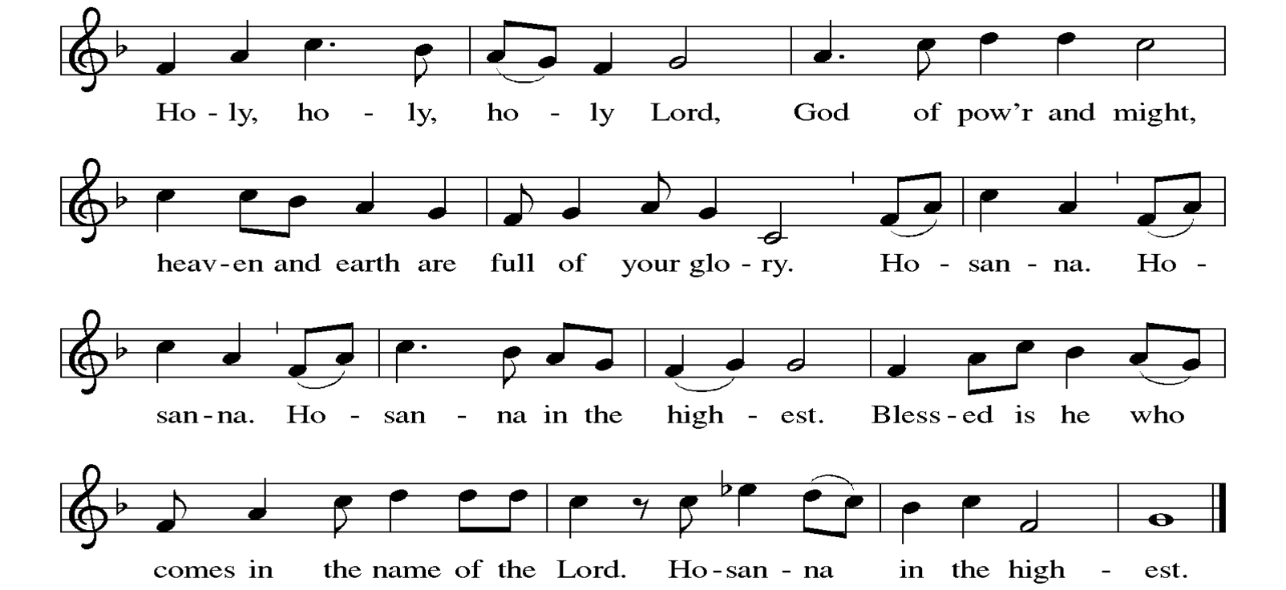
Illuminating God, source of creation, our salvation and our hope, we praise you for your creative labor, bearing expectations for life and love. When we strayed from your path and chose cruelty and despair, you spoke to us through unexpected prophets: Isaiah envisioned a blossoming desert; Mary proclaimed a world turned upside down; John the Baptist cried out for repentance. At this expectant hour, your Son Jesus came to bring us extraordinary love and to heal all the suffering world.

In the night in which he was betrayed, our Lord Jesus took bread, and gave thanks; broke it, and gave it to his disciples, saying: Take and eat; this is my body, given for you. Do this for the remembrance of me.
Again, after supper, he took the cup, gave thanks, and gave it for all to drink, saying: This cup is the new covenant in my blood, shed for you and for all people for the forgiveness of sin. Do this for the remembrance of me.

Remembering, therefore, his life among us, his death as one of us, and his resurrection, the first of all of us, we anticipate his coming in righteousness and peace.

Send your Spirit on us and on this meal we share: that we may work for justice, build hope for your already but not yet reign, and share the anticipated love and joy of your Son. All glory and honor is yours, in your holy creation, both now and forever. Amen.

LORD’S PRAYER
P: Gathered into one by the Holy Spirit, we pray as Jesus taught us.
C: Our Father in heaven, hallowed be your name, your kingdom come, your will be done, on earth as in heaven. Give us today our daily bread. Forgive us our sins as we forgive those who sin against us. Save us from the time of trial and deliver us from evil. For the kingdom, the power, and the glory are yours, now and forever. Amen.

Invitation to Communion P: Come and taste the joy of God! C: Amen.

The assembly is seated. 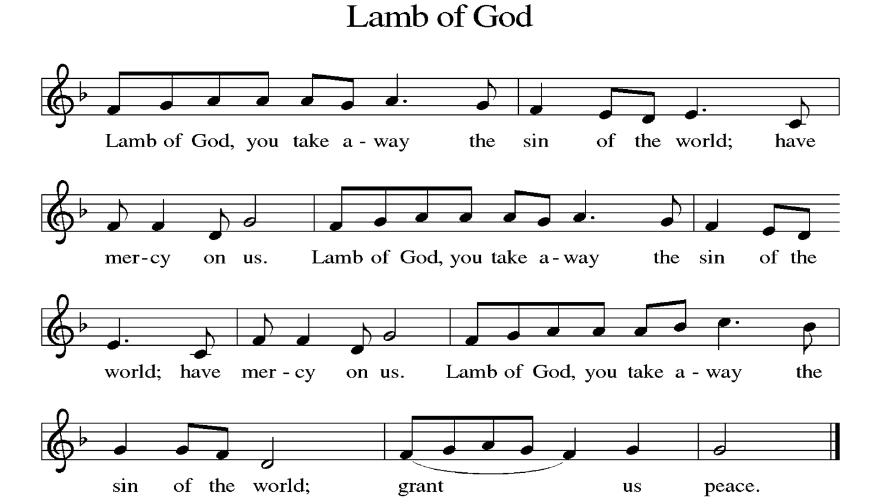

DISTRIBUTION
Time is given for the sharing of bread and wine. You may come forward to receive communion at the altar or partake with prepackaged elements at your seat. However communion is given and received, we trust Jesus is present in the bread and cup we share as a gathered community.

DISTRIBUTION HYMN One Bread, One Body ELW #496

Post-communion Blessing
The body and blood of our Lord Jesus Christ strengthen you God’s grace into life everlasting.
Amen

Prayer after Communion
P: Holy One,
we thank you for the healing
that springs forth abundantly from this table.
Renew our strength to do justice,
love kindness,
and journey humbly with you.
C: Amen.

ANNOUNCEMENTS
The assembly stands.

BLESSING
P: The God who faithfully brings forth justice
and breaks the oppressor’s rod
☩ bless, strengthen, and uphold you,
today and always.
C: Amen.

SENDING HYMN Praise the Lord, Rise Up Rejoicing ELW#544

DISMISSAL
L: Go in peace. Follow the way of Jesus.
C: Thanks be to God.

POSTLUDE “Abba, Father” Austin North

Announcements for the week of 2/11/23

- Council Meeting 2-13 7:00pm
- FIFTY PLUS BINGO AND PIZZA Fifty Plus will meet at 10:30, Wednesday, February 15, in the lower level of the church for another round of bingo and pizza. Please bring a wrapped white elephant for the prize table. The menu will be pizza, salad, ice cream, cookies, lemonade and coffee. Bring $7 to cover the cost of lunch. Sign up sheet will be on the bulletin board by February 4.
- Memorial Service for Donna Dasho will be February 17 @ LCLC

February 12, 2023
Preaching/Presiding:
Assisting Minister: Randy Henning
Lector: William Kaeppel
Zoom & Slides: Laurie & Gary
Musician: Greg Ott
Usher: Jann & Glenn Mueller
Greeter: Judy Holmes
Altar Guild: Doris Stoehner, Marilyn Wiley & Bill Kaeppel

February 19, 2023
Preaching/Presiding:
Assisting Minister: Bill Kaeppel
Lector: Angela Bennett
Zoom & Slides: Gary/Laurie Brown
Musician: Greg Ott
Usher: Glenn Albers & Ann Schultz
Greeter: Jann Mueller
Altar Guild: Maureen Buchek & Marjorie Becker

Coming Up at Living Christ

Monday 2/13 5:00pm Noble Guard
7:00pm Council Meeting
Tuesday 2/14 10:00am Bible Class
11:00am Exercise
7:00pm Bible Class (ZOOM)
Wednesday 2/15 10:30am 50+ Pizza & Bingo (LL)
Thursday 2/16 11:00am Exercise
Friday 2/17
Saturday 2/18 5:30pm Noble Guard
Sunday 2/19 8:00am Vocal Choir;
9:15am Worship
10:30am Adult Ed. Hour
11:00am True Vine Church of God

